University of Azad Jammu & Kashmir, MUzaffaarabad

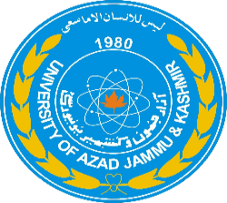

Department: Software Engineering
Course Title: Programming Fundamentals
Course Code: CS - 1101
Assignment Title and No: PF Project Proposal
Student Name: Syed Abdul Hanan Gillani
Roll No: 2025-SE-09
Instructor Name: Engr. Muhammad Awais
Submission Date: 29-01-2026

Introduction:
The Student Record Management System is a console-based application developed using C++ as part of the Programming Fundamentals course. The main purpose of this project is to demonstrate how basic programming concepts can be applied to solve a real-life problem.
This program helps in managing student records such as student ID, age, marks, percentage, and grade.
It uses a menu-driven approach, which makes the system simple and user- friendly for beginners.

Core Features:
The core features of the project are:
- Add new student records
- Store multiple student details using arrays
- Calculate percentage automatically
- Assign grades based on percentage
- Display all student records
- Search student record using Student ID
- Update existing student information
- Delete student records
- Display pass/fail status
- Show total number of registered students
- Menu-driven continuous execution until exit

Flow Chart:
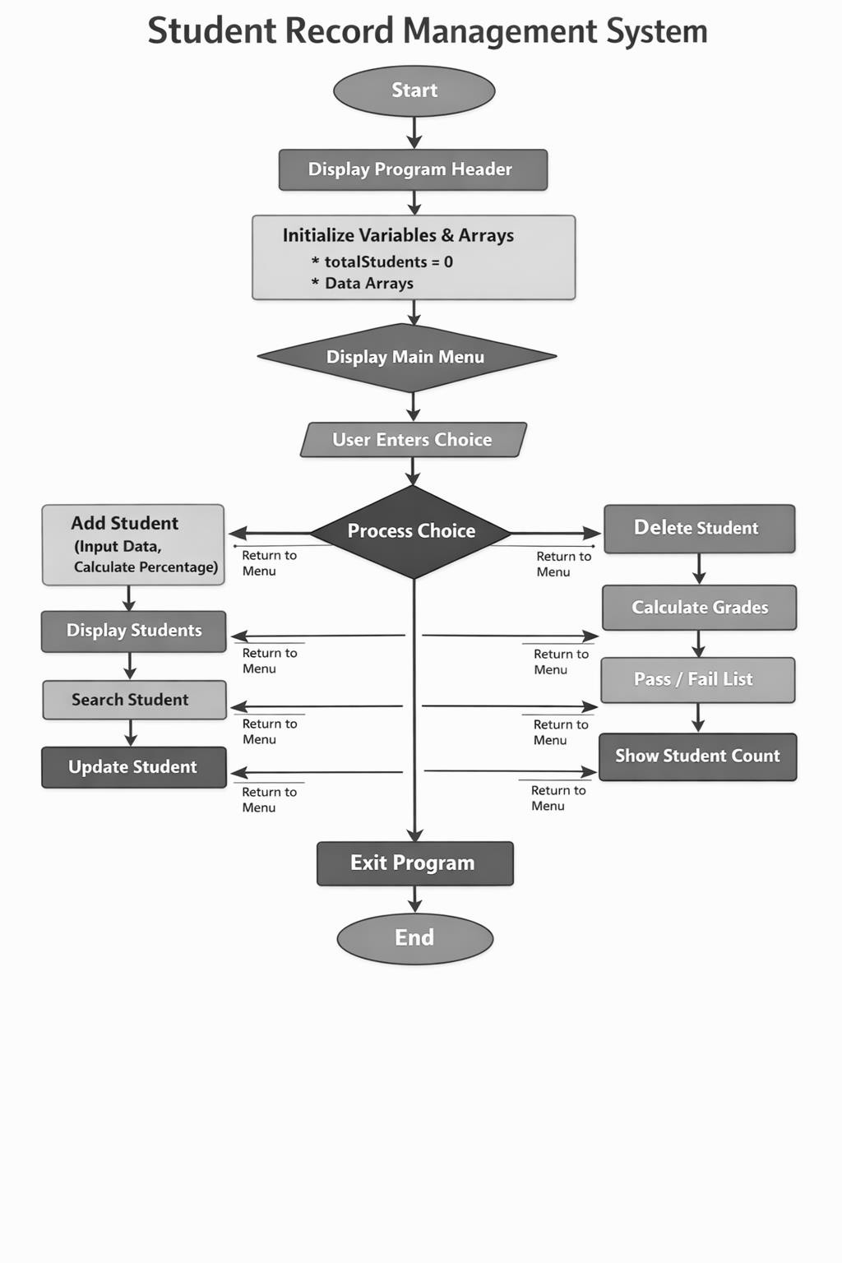
Output:
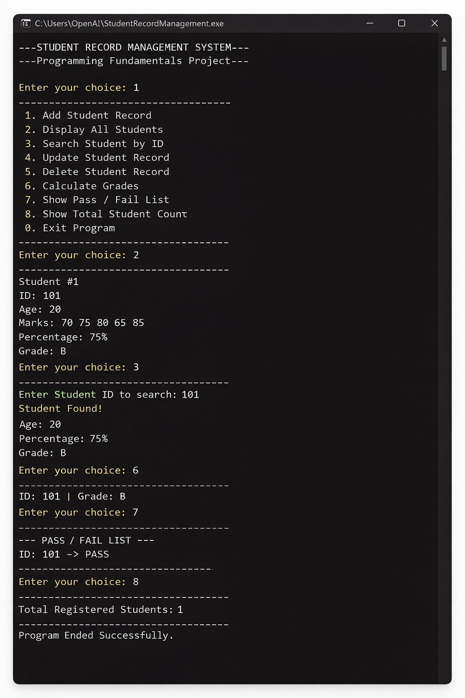

Conclusion:
The Student Record Management System successfully demonstrates the practical application of Programming Fundamentals in C++. Using a menu-driven approach, the program allows easy management of multiple student records with the help of arrays, functions, loops, and conditional statements. Important concepts like call by reference, constants, and 2D arrays were implemented to improve program structure and efficiency.This project helped strengthen problem-solving and logical thinking skills, while providing a foundation for future enhancements such as file handling and object-oriented programming. Overall, it is a simple, user-friendly, and functional program suitable for beginners.

